NLP Applications - Assignment 2 – PS-7 (Part A – TASK B)

Group 39
Group Member Names:
- Akilan K. S. L., 2024AB05003
- Devender Kumar, 2024aa05065
- Nagendra Prasad Reddy K. V. S., 2024aa05960
- Sai Venkata Naga Sesh Kumar Ghanta, 2024aa05989
- Piramanayagam P., 2024AB05015

Table of Contents
Problem Definition: PART A - Task B : Enhancement Plan (2 Marks) 3
Enhancement Plan 4
Summary: 4
Details of all enhancements in steps: (Refactor code into a clean service layer) 4
Step 1 : Restructure - UI (HTML) and APIs call the same core inference function. 5
Step 2 — Define API contract (inputs/outputs) 5
Step 3 — Implement REST endpoints in Flask using Blueprints 6
Step 4 — Add input validation + security defaults 6
Step 5 — Add versioning and documentation (OpenAPI) 7
Step 6 — Performance improvements for API mode 7
Step 7 — Logging, monitoring, and error handling 7
Step 8 — Testing (very important for “detailed documentation”) 8
Step 9 — Deployment plan 8
Appendix: 10
Evidences of executing in BITS OSHA Cloud lab 11
Design & Flows 13

Problem Definition: PART A - Task B : Enhancement Plan (2 Marks)
Provide a detailed documentation that would explain the step – by- step process to enhance your Sentiment Analysis Application to develop and expose RESTful APIs that allow external applications to access the sentiment analysis engine.

Enhancement Plan

Summary:
REST APIs for Sentiment Analysis Application (preprocessing + model inference) through REST endpoints such as:
- POST /api/v1/sentiment → analyze a text string
- POST /api/v1/sentiment/batch → analyze multiple texts
- POST /api/v1/sentiment/file → analyze an uploaded .txt file
- GET /api/v1/health → health check for monitoring

Details of all enhancements in steps: (Refactor code into a clean service layer)
- Restructure code
- API contracts
- REST implementation
- Validation & Security
- Versioning & Documentation
- Performance Improvements
- Logging, Metrics and Error Handling
- Testing
- Deployment Plan

Step 1 : Restructure - UI (HTML) and APIs call the same core inference function.
project/app.py # Flask entry
sentiment/preprocess.py # cleaning/tokenization/lemmatization
model.py # load model + predict
service.py # sentiment_pipeline(text) orchestration
api/routes.py # API endpoints (Blueprint)
schemas.py # request/response validation helpers
templates/ # existing UI
static/ # existing UI assets
In sentiment/service.py, create a single callable:
- analyze_text(text: str) -> dict
  - returns: label, confidence, optional scores, cleaned text, etc.

Step 2 — Define API contract (inputs/outputs)
2.1 Request format (JSON)
For single text:
{ "text": "I love this product!" }
Optional fields you can support:
return_scores: true/false
language: "en" (if you later add multilingual support)
2.2 Response format (JSON)
{
"request_id": "uuid",
"label": "positive",
"confidence": 0.91,
"scores": { "positive": 0.91, "neutral": 0.07, "negative": 0.02 },
"processing_ms": 12
}
2.3 Standard error format
{
"request_id": "uuid",
"error": {
"code": "INVALID_INPUT",
"message": "Field 'text' must be a non-empty string."
}
}

Step 3 — Implement REST endpoints in Flask using Blueprints
Create a blueprint api/routes.py and register it in app.py under /api/v1.
Health
GET /api/v1/health
Returns: status OK + model loaded + version
{ "status": "ok", "model_loaded": true, "version": "1.0.0" }
Single text inference
POST /api/v1/sentiment
Body: { "text": "..." }
Returns: label + confidence (+ scores optional)
Batch inference
POST /api/v1/sentiment/batch
Body:
{ "texts": ["Good", "Bad", "Okay"] }
Returns list of results with indices.
File upload
POST /api/v1/sentiment/file
multipart/form-data with file=@input.txt
Server reads file content → analyze.

Step 4 — Add input validation + security defaults
Validation rules
- text must be string, trimmed, length > 0
- Set max length (example: 5,000 chars) to prevent abuse
- For batch: max items (example: 100)
Security & hardening
- Disable debug in production
- Add CORS if external frontend/mobile apps will call it
- Add basic API key auth (simple and assignment-friendly)
API key approach
- Client sends: Authorization: Bearer <API_KEY>
- Server checks it against env var API_KEY

Step 5 — Add versioning and documentation (OpenAPI)
Versioning
Use /api/v1/... so you can add /api/v2/... later without breaking clients.
Documentation
a simple README.md section with curl examples

Step 6 — Performance improvements for API mode
Few points:
- Load model once at startup, not per request
- Keep preprocessing objects (tokenizer/vectorizer) in memory

Step 7 — Logging, monitoring, and error handling
Logging
- Log per request:
- request_id
- endpoint
- processing time
- errors (stack trace only in server logs)
Monitoring essentials
- /health endpoint for uptime checks
- response time tracking (processing_ms)
Consistent error handling
Use Flask error handlers for:
400 (bad request)
401 (unauthorized)
500 (server error)

Step 8 — Testing (very important for “detailed documentation”)
- Unit tests
- preprocessing functions
- model prediction function
- API tests
- Use Flask test client or pytest:
- valid request returns 200 + expected schema
- empty text returns 400 with INVALID_INPUT
- missing/invalid API key returns 401
Manual tests (curl examples)
curl -X POST http://localhost:5000/api/v1/sentiment \
-H "Content-Type: application/json" \
-H "Authorization: Bearer YOUR_KEY" \
-d '{"text":"This is amazing"}'

Step 9 — Deployment plan
Local run
- python app.py (or flask run)
Production run
- Use a WSGI server:
- gunicorn app:app
Add config via environment variables:
- API_KEY
- MODEL_PATH
- MAX_TEXT_LENGTH
- LOG_LEVEL
Deploying on Docker:
- Dockerfile builds image
- container exposes port 5000
- env vars injected at runtime

Appendix:

1. API Endpoint Table
Endpoint | Method | Purpose
/api/v1/health | GET | Health + readiness
/api/v1/sentiment | POST | Single text inference
/api/v1/sentiment/batch | POST | Batch inference
/api/v1/sentiment/file | POST | File upload inference

2. Evidence of executing in BITS OSHA Cloud lab

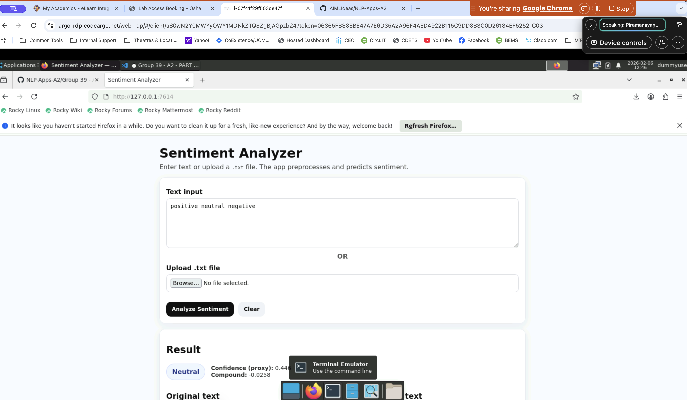

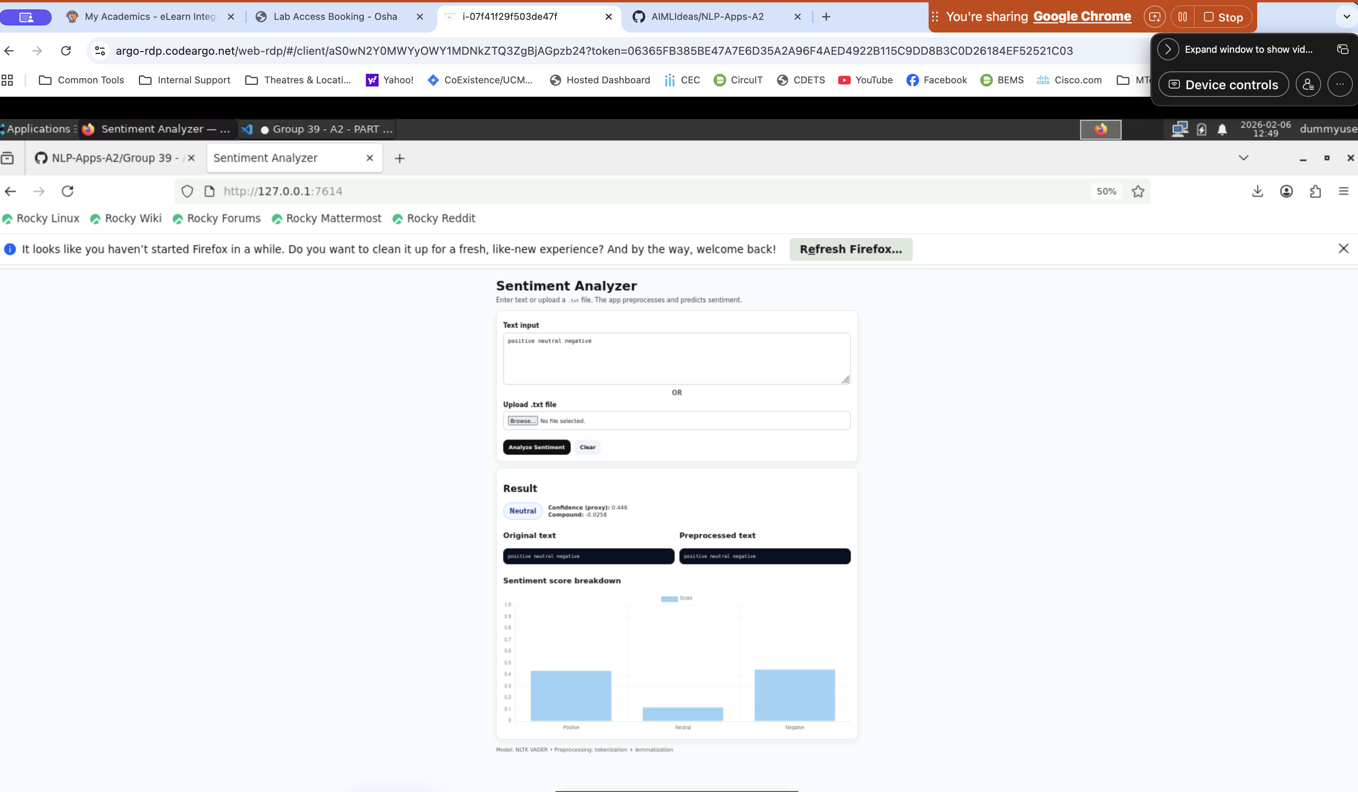
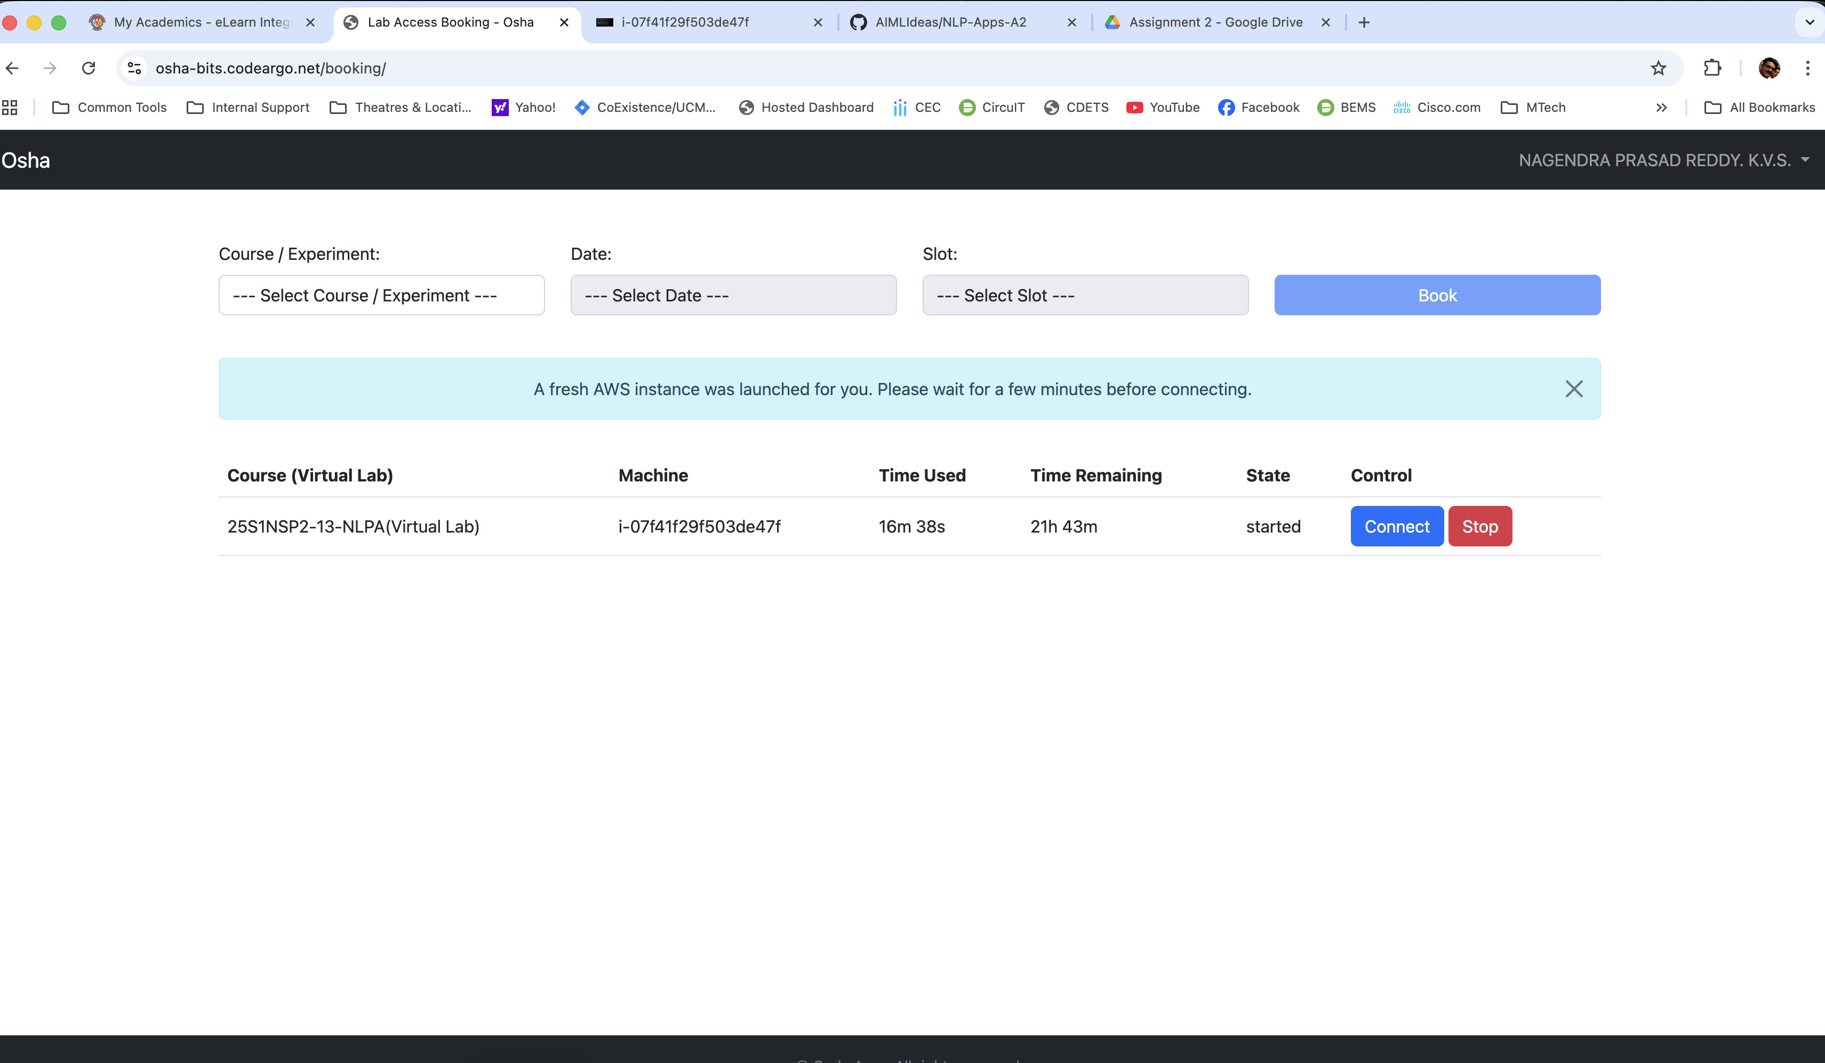

3. Design & Flows
